DR. A.N.K DAV PUBLIC SCHOOL, ROURKELA -12
SCHOOL UNIFORM : 2015-16
As per the directive of DAVCMC, New Delhi, all DAV Schools of the country will follow the same School Uniform, as per the following details, to have common identity among the students of DAV Schools of the entire country.
School uniform is discipline in itself and must be adhered to strictly.
Girls | Boys
NURSERY TO UKG
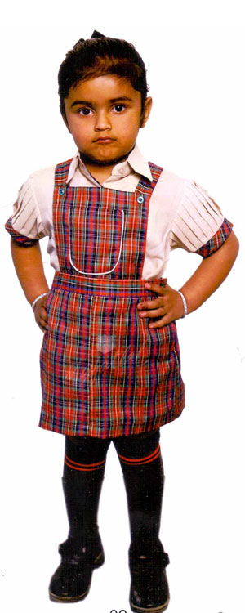 | 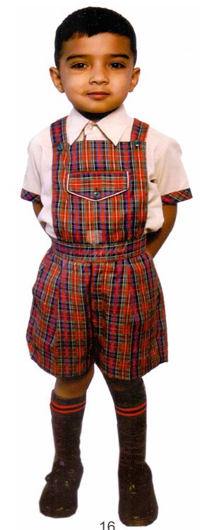
Regular Uniform  - Fawn Shirt with Checks on Pleated Sleeve Border  - Checked gallace skirt with pocket | Regular Uniform  - Fawn Shirt with Checked Border on shirt  - Checked shorts with Gallace and pocket
STD. – I & II
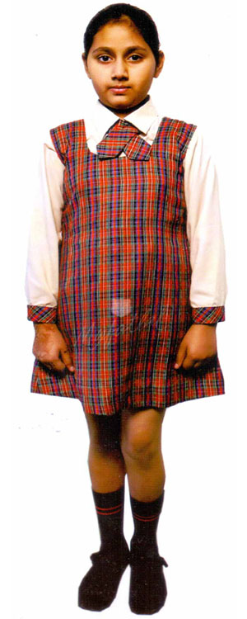 | 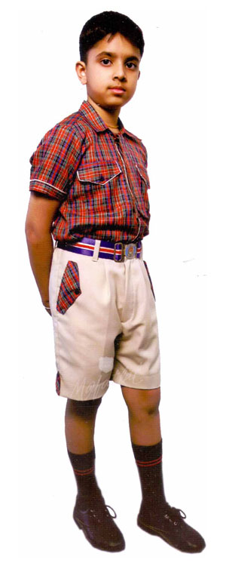
Regular Uniform :  - Fawn Shirt with Checked cuffs  - Checked tie. Checked tunic  PT Uniform (Thursday): White Shirt and White Tunic | Regular Uniform :  - Checked shirt with Piping on sleeves (Half) and pockets  - Fawn shorts with checked accents.  PT Uniform (Thursday): White Shirt and White Nicker
STD. III TO V
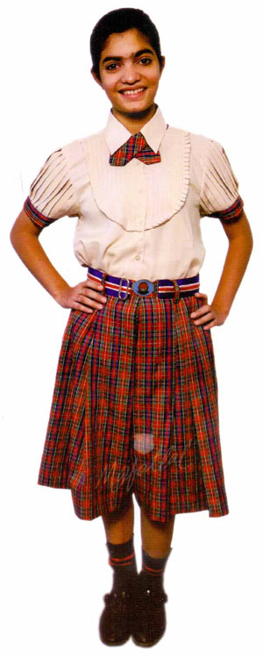
Regular Uniform  - Fawn Shirt with Checks on Pleated Sleeve Border on pleated sleeves  - Checked tie. Checked pleated Divider skirt.  PT Uniform(Thursday):White Shirt with White Divider  Skirt. |  | Regular Uniform  1.Checked shirt with Piping on sleeves (Half) and pockets  2. Fawn shorts with checked accents.  PT Uniform(Thursday):White Shirt with White half pant.
STD. VI TO VIII
 |  | 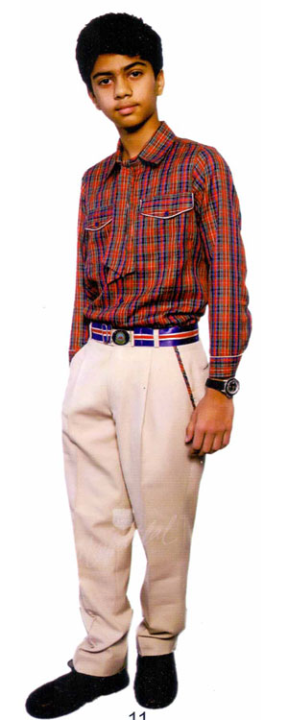
Regular Uniform  - Fawn Shirt with Checks on Pleated Sleeve Border on pleated sleeves. Checked tie  - Checked pleated Divider skirt.  PT Uniform (Thursday):White Shirt with White Divider  Skirt. |  | Regular Uniform:  Checked shirt with piping on sleeves and pockets  - Full Sleeve ( From November to February)  2.Half Sleeve ( March to October). Fawn Colour Full Pant.  PT Uniform (Thursday):White Shirt with white Full Pant.
STD. IX TO XII
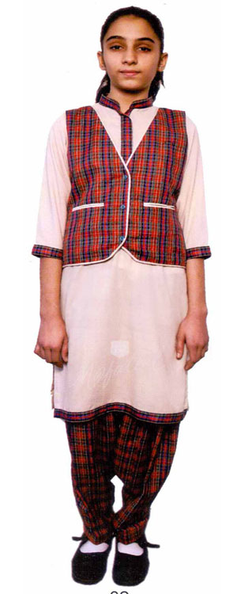
Regular Uniform  - Fawn Coloured kurta with checked border on neck, button and sleeves.  - Checked Salwar. Checked waistcoat with fawn piping.  PT Uniform (Thursday):  White Salwar Kameez with White Waist coat |  | Regular Uniform  - Checked shirt with piping on sleeves and pockets  - Full Sleeve ( From November to February)  - Half Sleeve ( March to October)  - Fawn Colour Full Pant.  PT Uniform (Thursday): White Shirt with white Full Pant.
Note :-
- Fawn colour socks with stripes and Brown shoes for all. White shoes (Beta canvas) and white socks for PT Uniform. The design of PT Uniform is same as Regular Uniform
- White ribbon/hair band is compulsory for all girls students from std-I to std- XII on all days.
- Black slacks (3/4 tights) for Yoga and dance classes / winter days.
- White apron for lab uses for Classes XI & XII (Science stream).
- School Identity card is compulsory.
- Detail design with colour both for boys and girls will be displayed in the school website/notice board.
- The time frame for change in uniform is three years.
- Winter uniforms for all classes as displayed in the school website/ Notice board are to be followed from 1st Nov to last February every year.
- Blazer is compulsory from Std - VI to Std. - XII.
- This new uniform guideline is issued as per the decision of DAV College managing Committee vide its letter No. – DAVCMC/3414 dated 10.11.2014.
- The School does not recommend any brand name/ company/shops to purchase uniform. However all should use cotton filled clothes for comfort as per the photographs enclosed. But the design of the uniform as required to be followed as per the specifications shown in the photographs.
Principal.

